HOW TO GIVE RS. 50 OFF FOR GIVING 5 STAR GOOGLE REVIEWS
STEP : 1
Go to Superapp. Click Records. Then click Store credits.
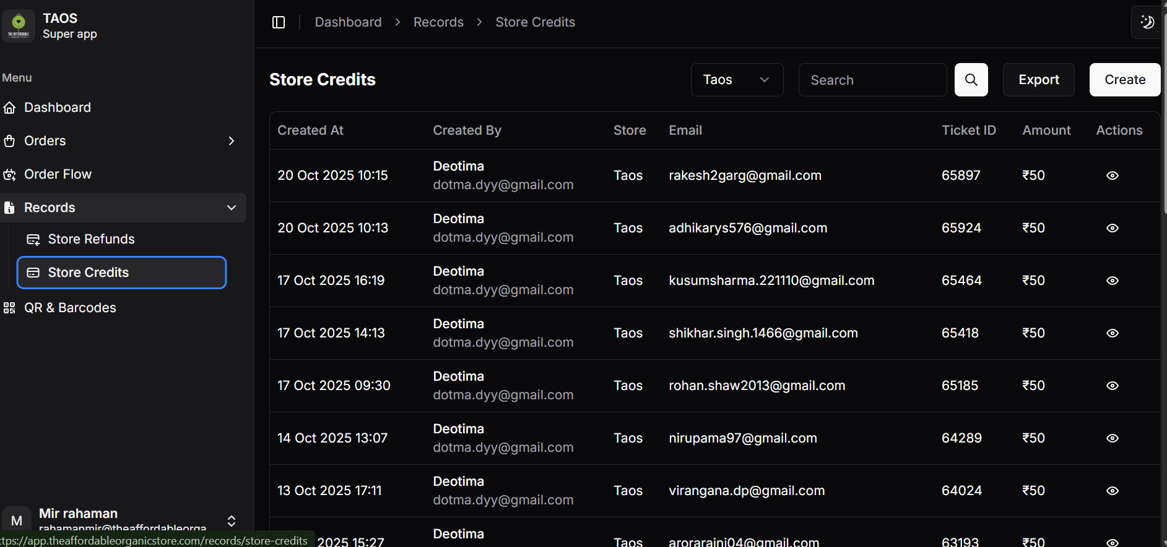
STEP : 2
Click create
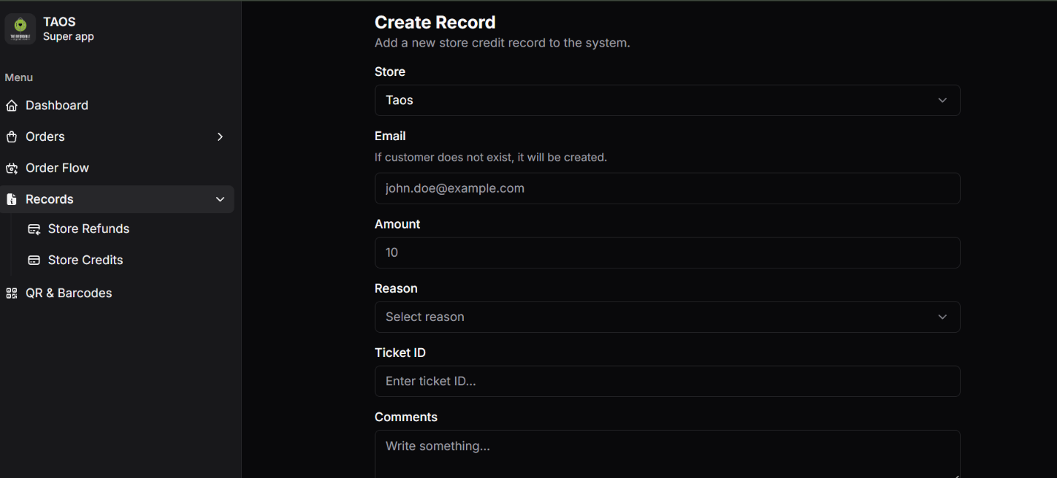

STEP : 3
Put customer email id in Email. Enter amount as 50. Select Reason as 5 star review. Enter Ticket ID. Write comments – “Rs. 50 Store Credit for 5 star review”
STEP : 4
Upload the screenshot of 5 star review customer shared.

STEP : 5
Click submit.

